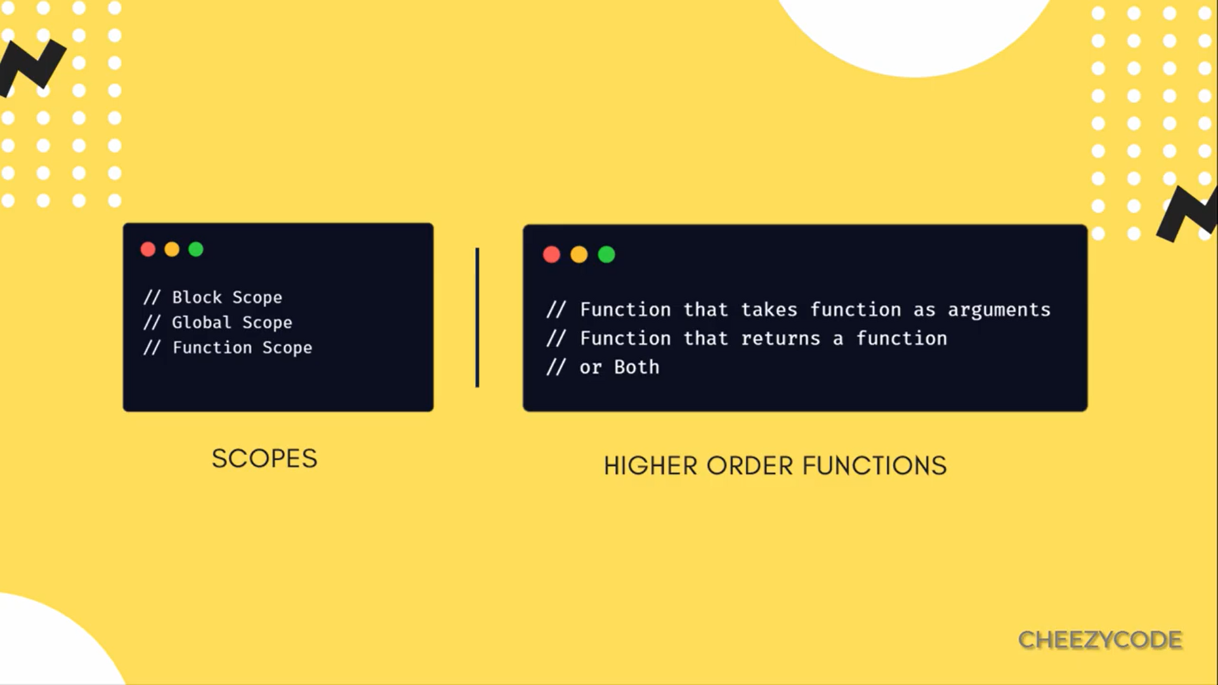

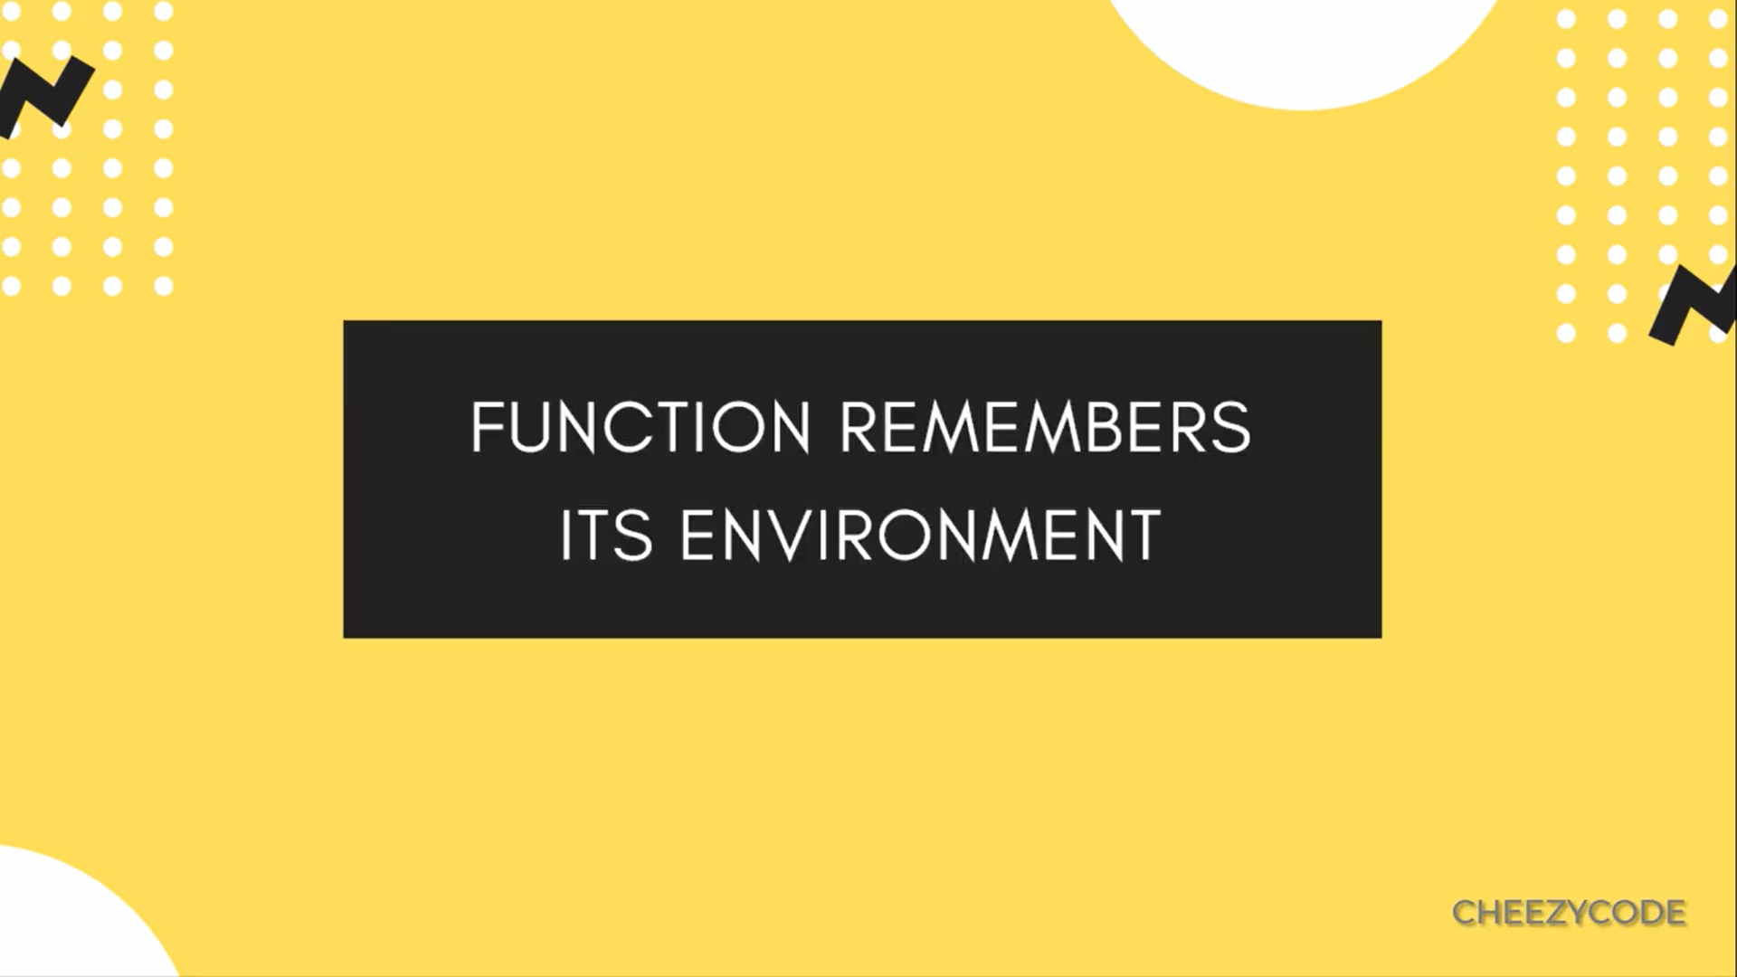

When we create a function , it remembers its env (means variables)

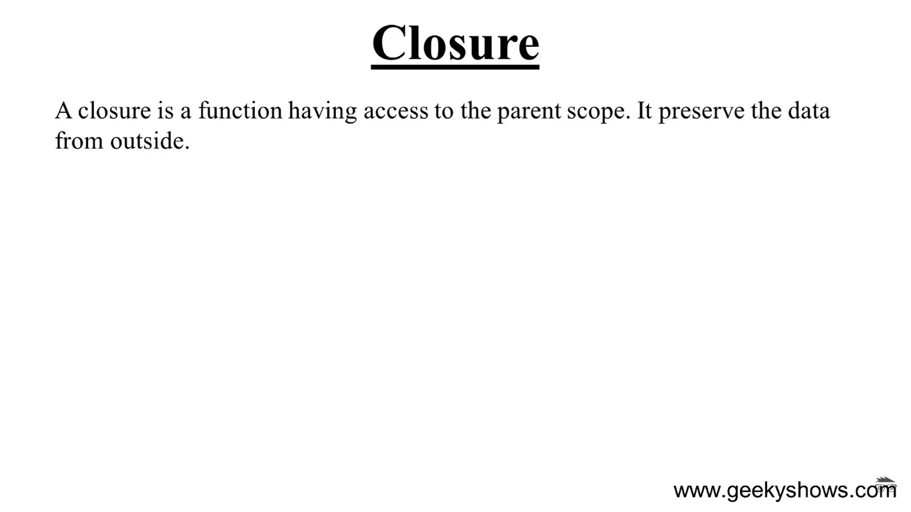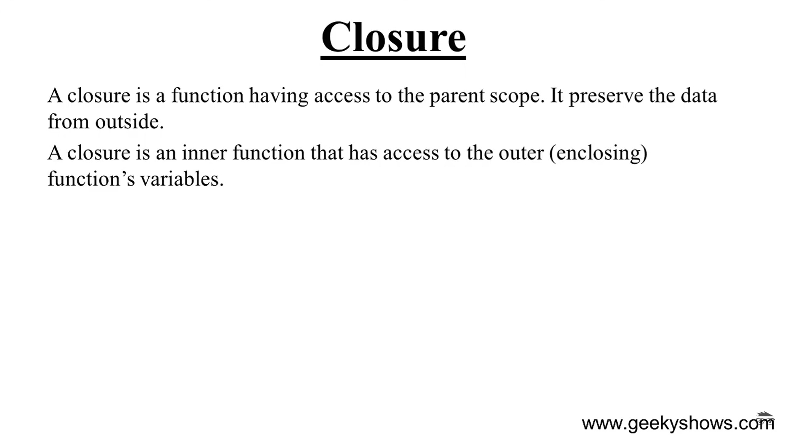

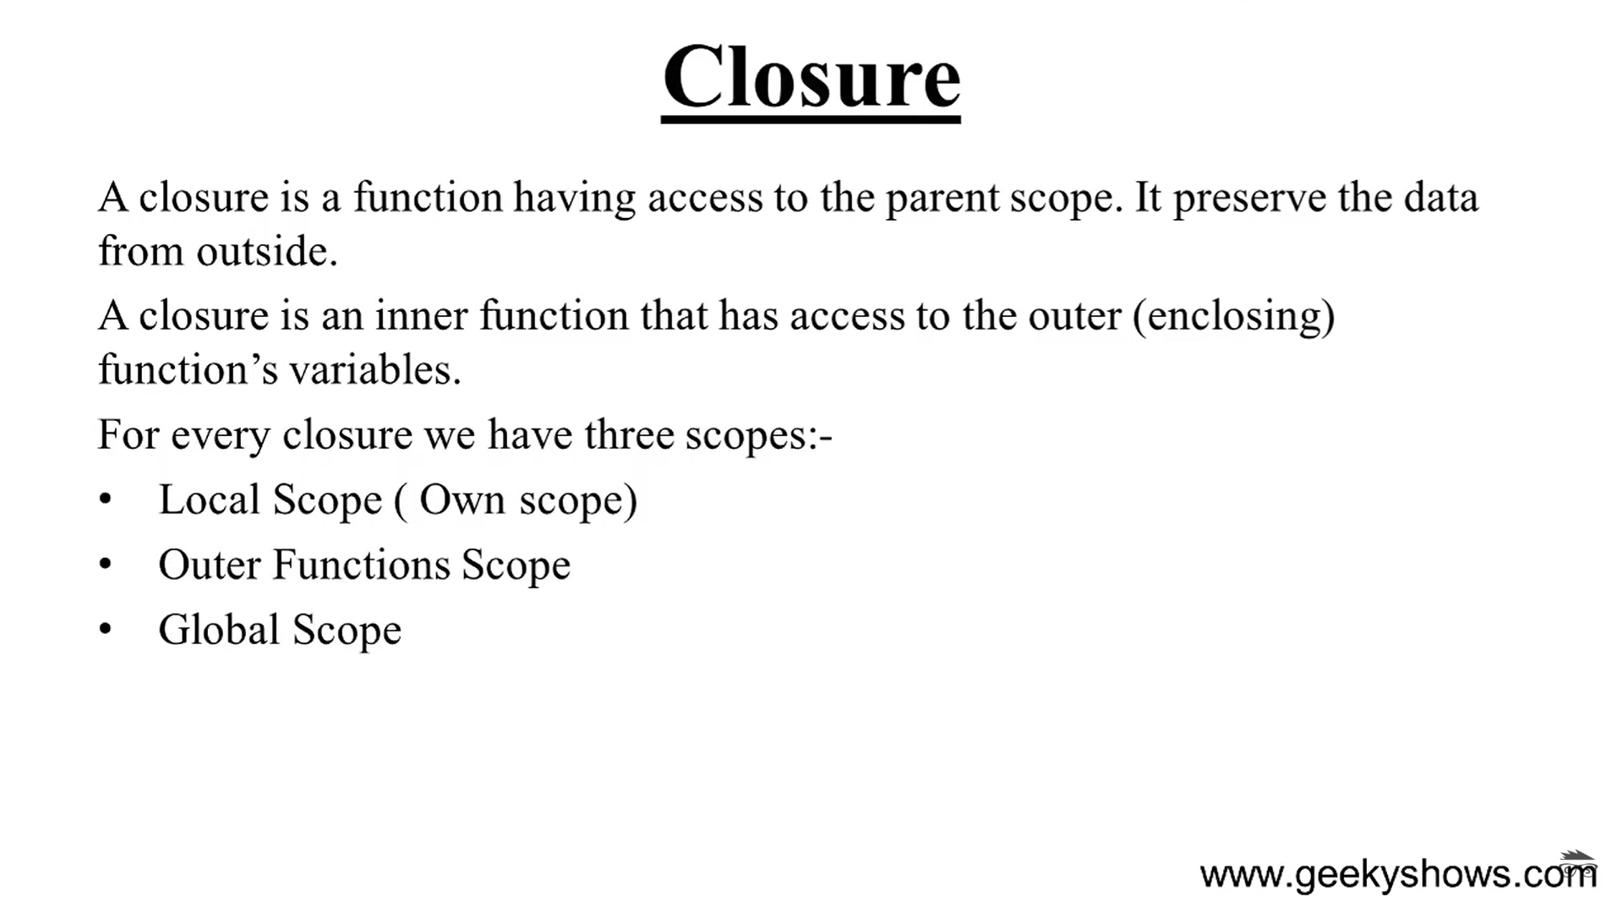

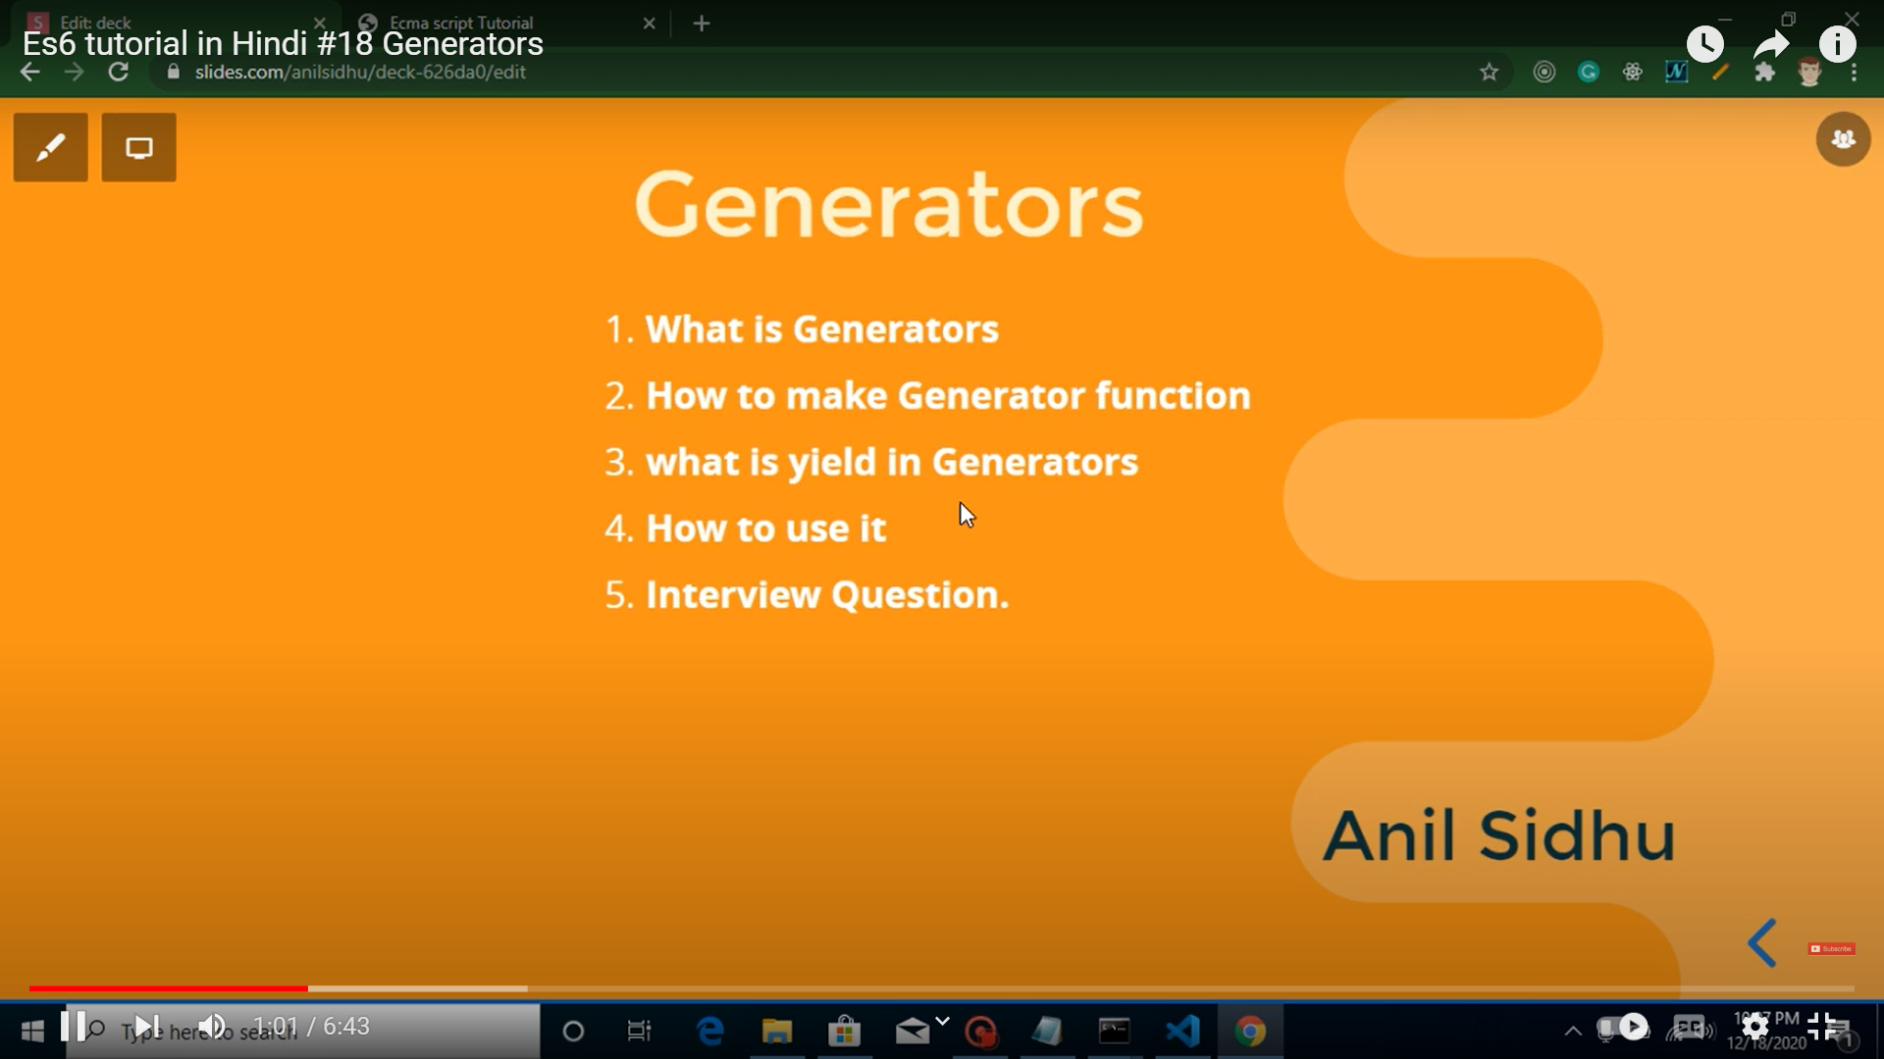

In ECMAScript 2015, generators were introduced to the JavaScript language. A generator is a process that can be paused and resumed and can yield multiple values. A generator in JavaScript consists of a generator function, which **returns an iterable Generator object**.